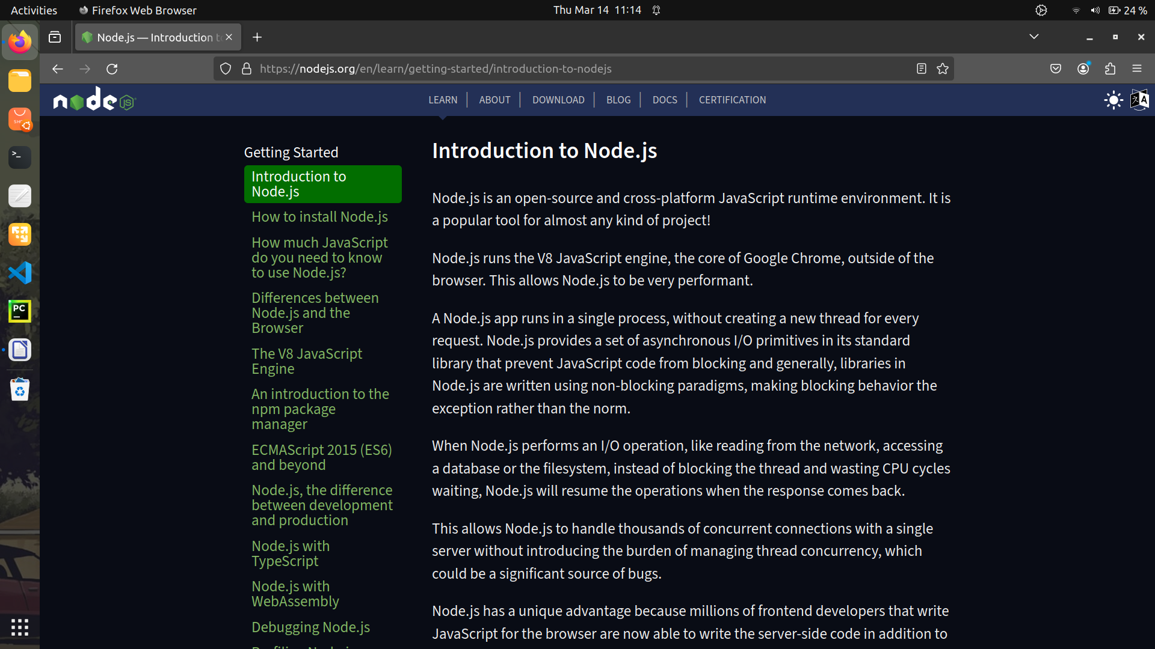
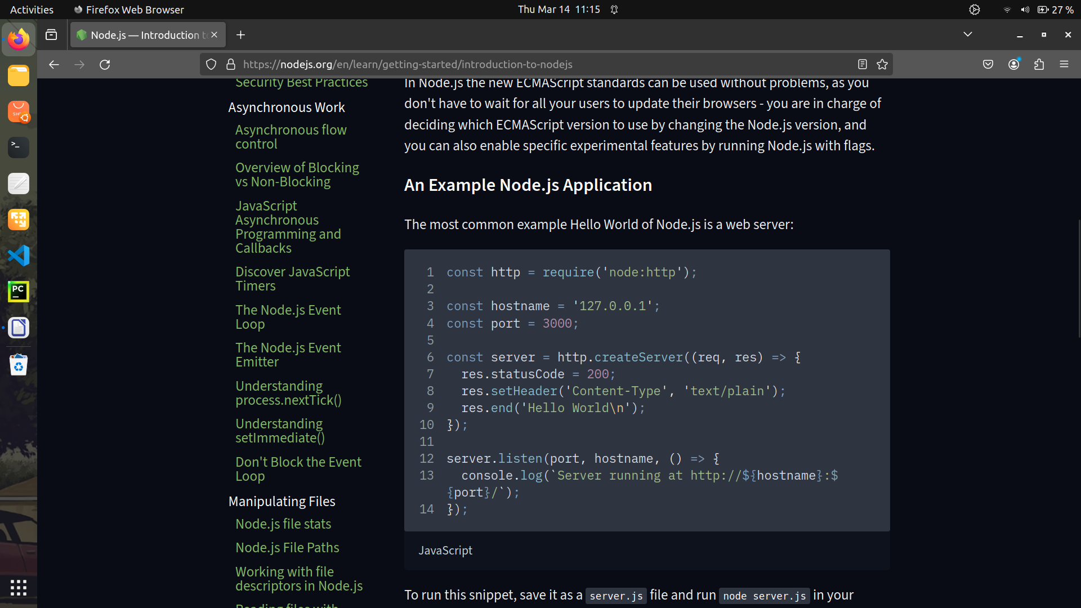
To run this snippet, save it as a server.js file and run node server.js in your terminal.

This code first includes the Node.js http module.

Node.js has a fantastic standard library, including first-class support for networking.

The createServer() method of http creates a new HTTP server and returns it.

The server is set to listen on the specified port and host name. When the server is ready, the callback function is called, in this case informing us that the server is running.

Whenever a new request is received, the request event is called, providing two objects: a request (an http.IncomingMessage object) and a response (an http.ServerResponse object).

Those 2 objects are essential to handle the HTTP call.

The first provides the request details. In this simple example, this is not used, but you could access the request headers and request data.

The second is used to return data to the caller.
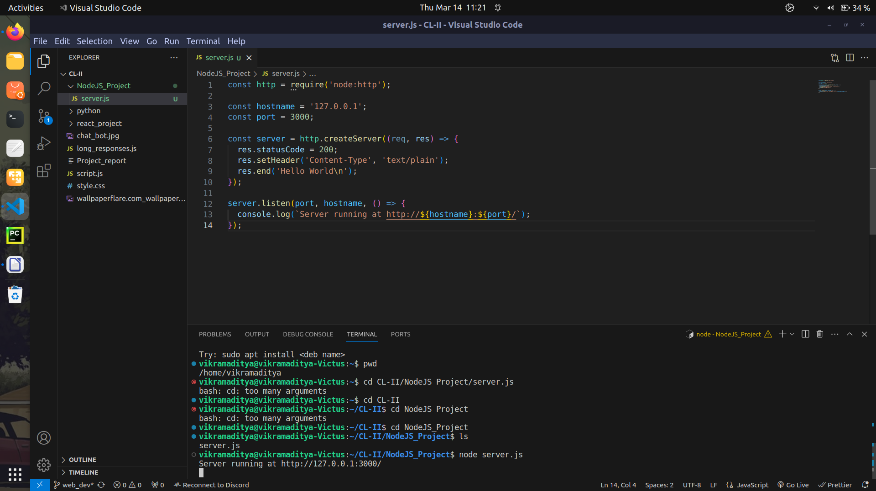
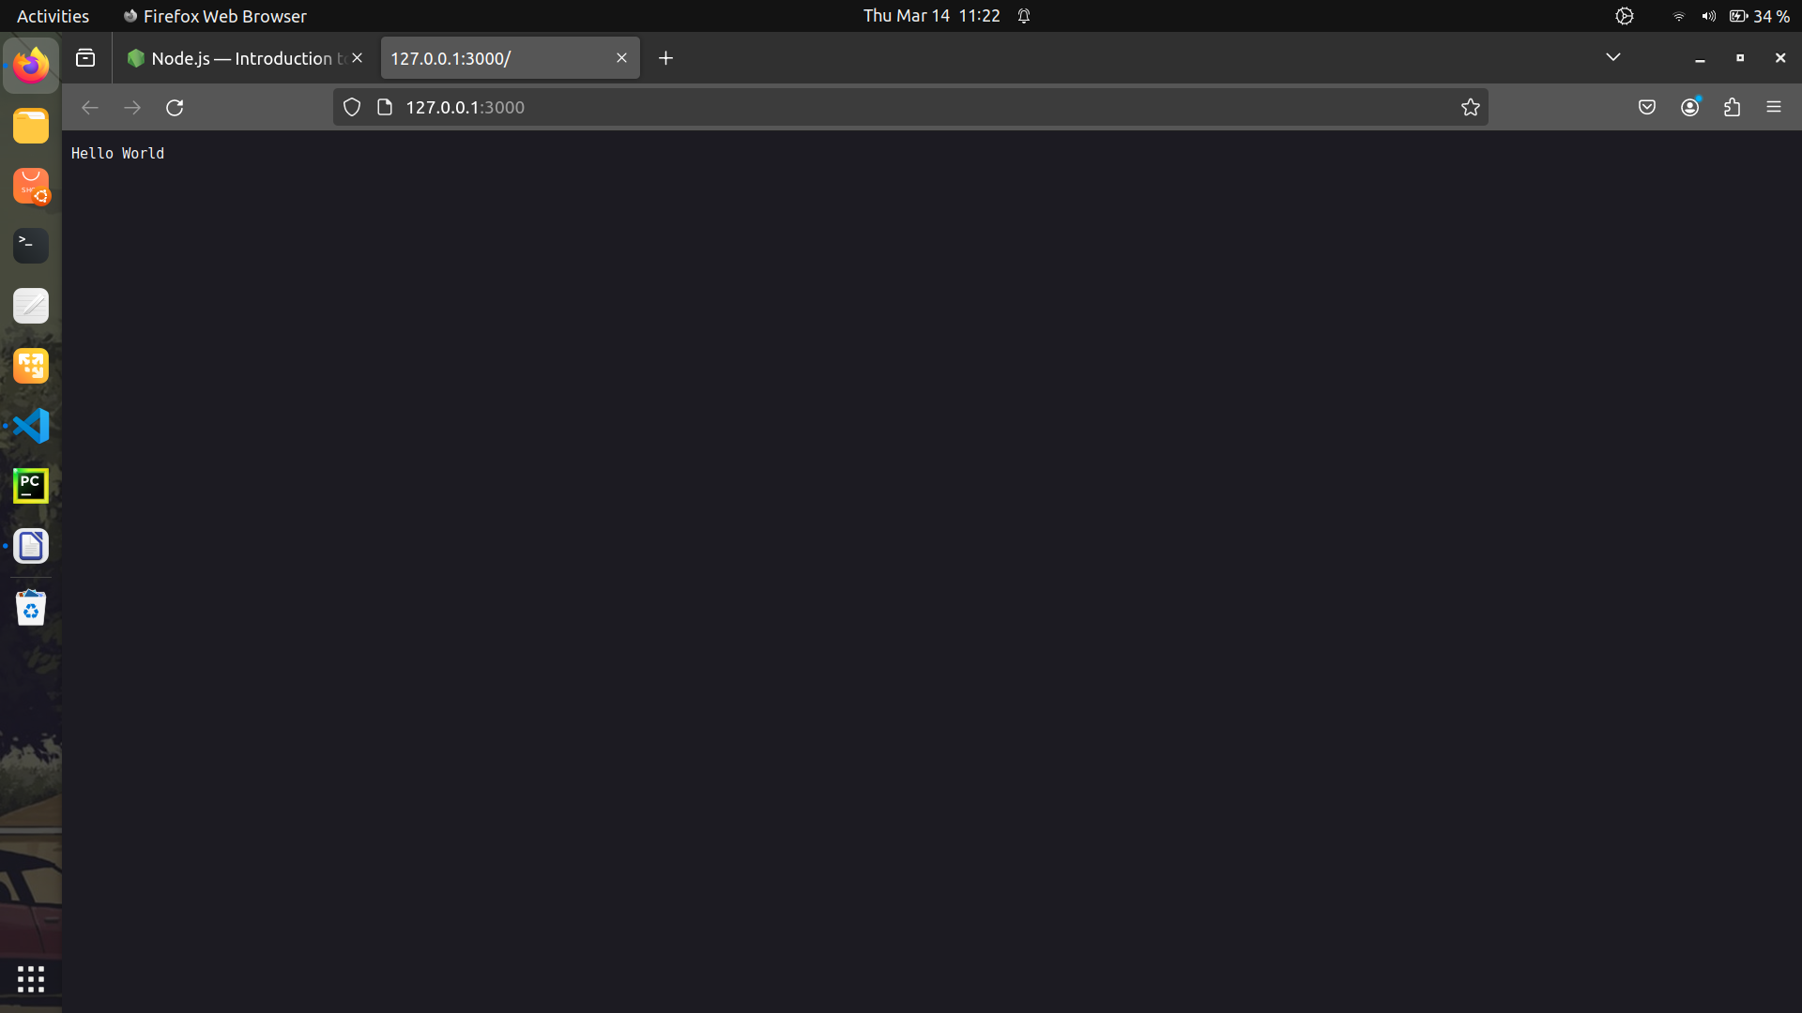
In this case with:

res.statusCode = 200;
we set the statusCode property to 200, to indicate a successful response.
We set the Content-Type header:

res.setHeader('Content-Type', 'text/plain');

and we close the response, adding the content as an argument to end():

res.end('Hello World\n');

The Node.js file system module allows you to work with the file system on your computer.
To include the File System module, use the require() method:
var fs = require('fs');
Common use for the File System module:
- Read files
- Create files
- Update files
- Delete files
- Rename files

Read Files
The fs.readFile() method is used to read files on your computer.
Assume we have the following HTML file (located in the same folder as Node.js):
demofile1.html
<html>
<body>
<h1>My Header</h1>
<p>My paragraph.</p>
</body>
</html>
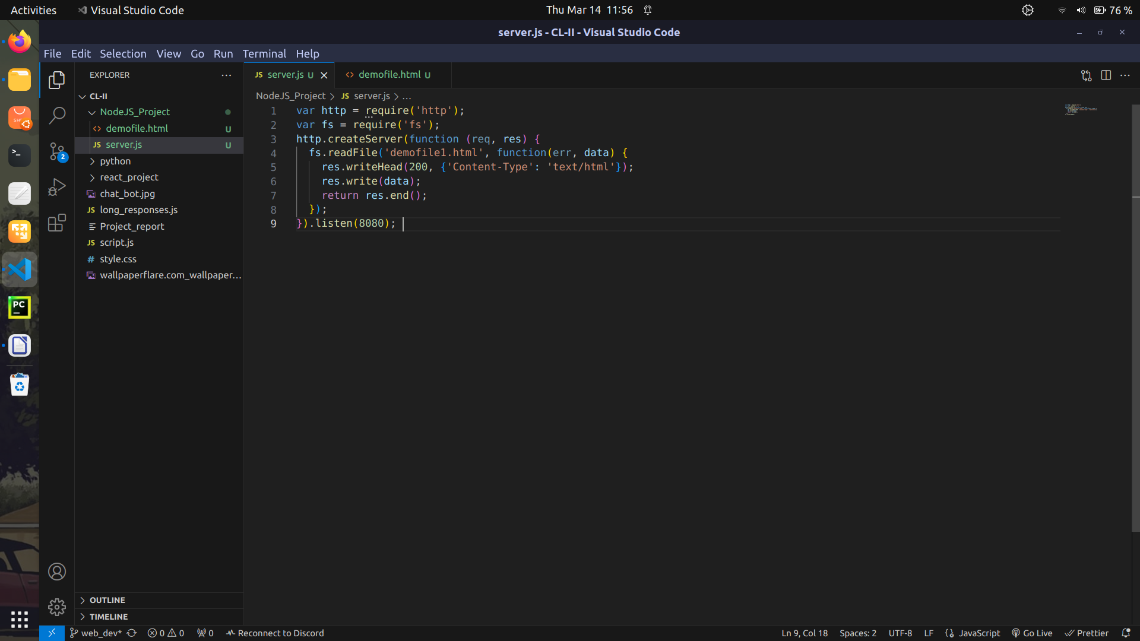

Events in Node.js
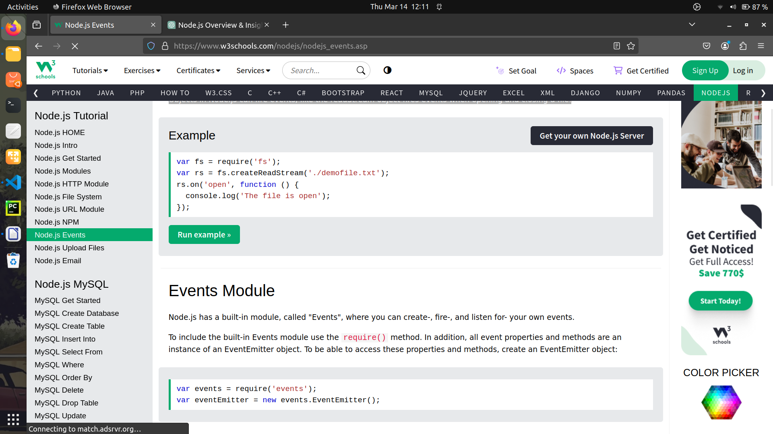
Every action on a computer is an event. Like when a connection is made or a file is opened.
Objects in Node.js can fire events, like the readStream object fires events when opening and closing a file:

Upload Files
Now we are ready to make a web page in Node.js that lets the user upload files to your computer:

Step 1: Create an Upload Form
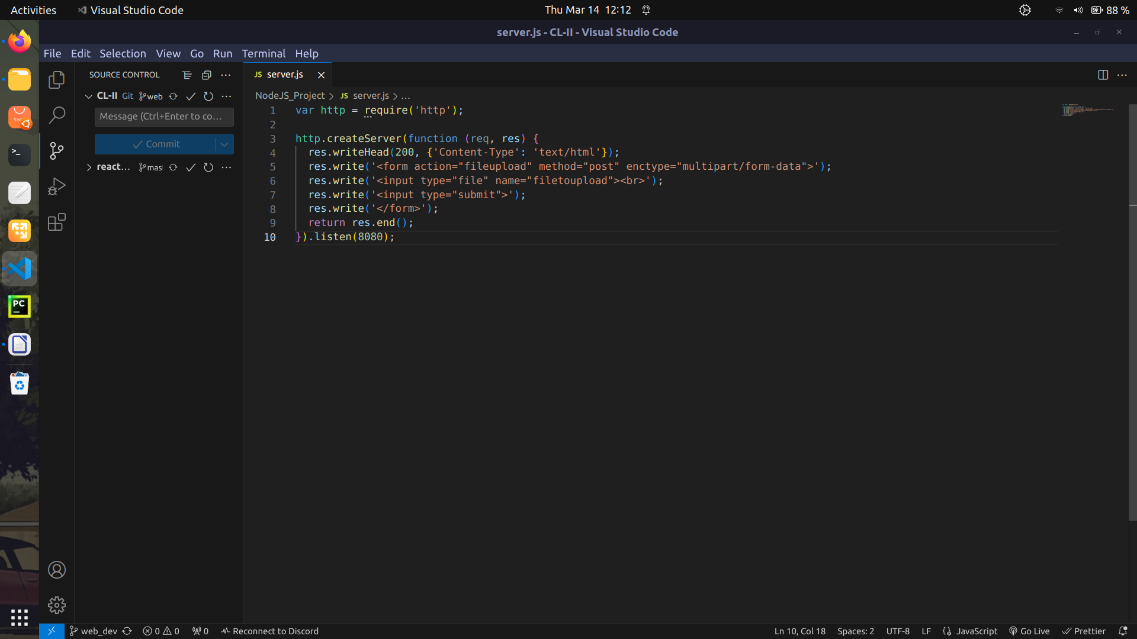
Create a Node.js file that writes an HTML form, with an upload field:

Step 2: Parse the Uploaded File
Include the Formidable module to be able to parse the uploaded file once it reaches the server.
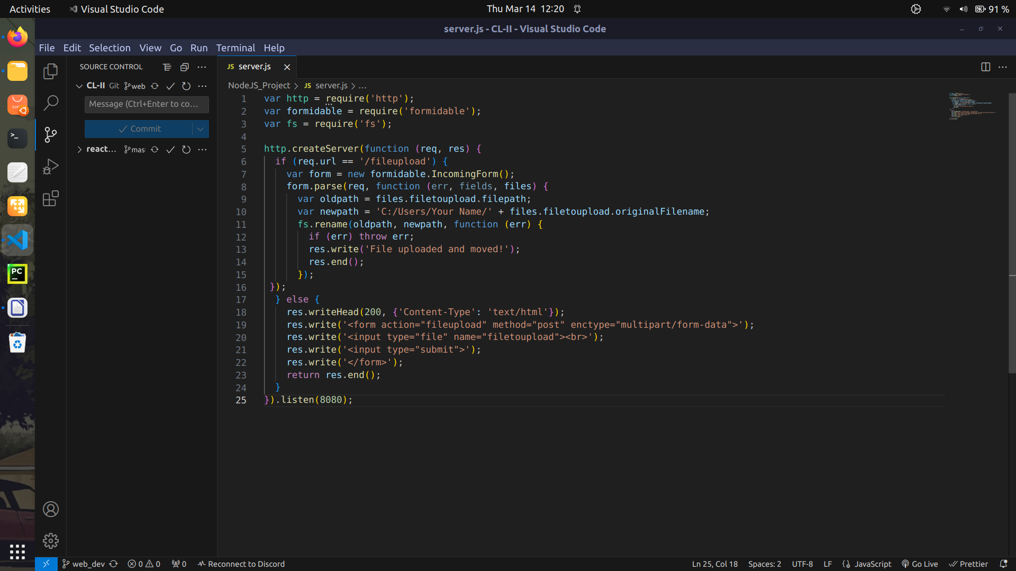
When the file is uploaded and parsed, it gets placed on a temporary folder on your computer.

Step 3: Save the File
When a file is successfully uploaded to the server, it is placed on a temporary folder.
The path to this directory can be found in the "files" object, passed as the third argument in the parse() method's callback function.
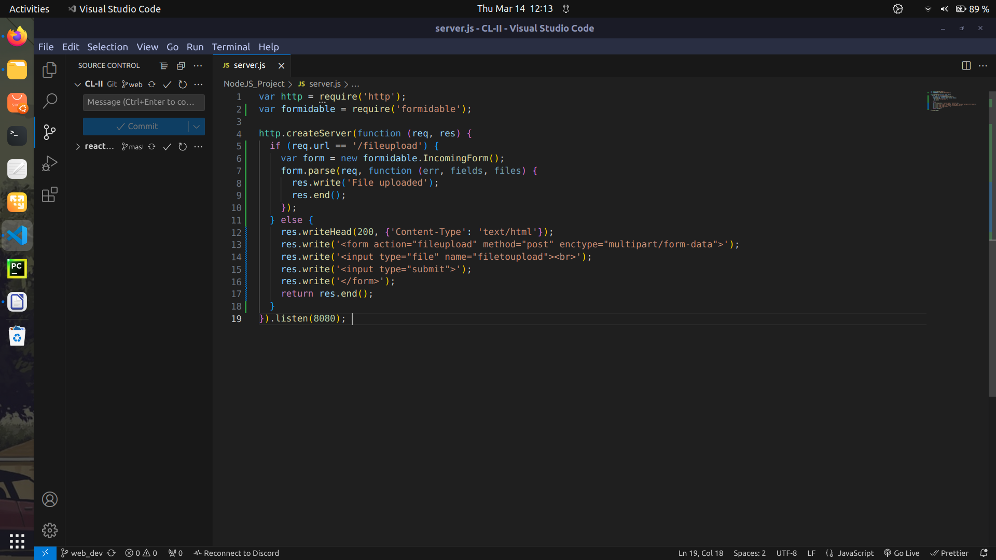
To move the file to the folder of your choice, use the File System module, and rename the file:

The Nodemailer Module
The Nodemailer module makes it easy to send emails from your computer.
The Nodemailer module can be downloaded and installed using npm:
npm install nodemailer

After you have downloaded the Nodemailer module, you can include the module in any application:
var nodemailer = require('nodemailer');

Multiple Receivers
To send an email to more than one receiver, add them to the "to" property of the mailOptions object, separated by commas:

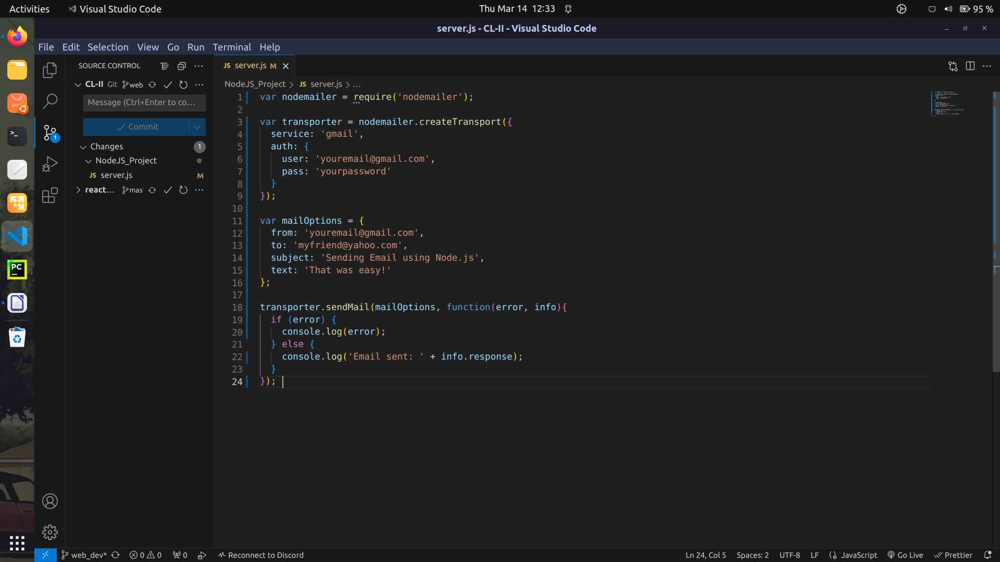
Multiple Receivers
To send an email to more than one receiver, add them to the "to" property of the mailOptions object, separated by commas:
var mailOptions = {
from: 'youremail@gmail.com',
to: 'myfriend@yahoo.com, myotherfriend@yahoo.com',
subject: 'Sending Email using Node.js',
text: 'That was easy!'
}

Send HTML
To send HTML formatted text in your email, use the "html" property instead of the "text" property:
var mailOptions = {
from: 'youremail@gmail.com',
to: 'myfriend@yahoo.com',
subject: 'Sending Email using Node.js',
html: '<h1>Welcome</h1><p>That was easy!</p>'
}

Basic Syntax Of NodeJS
Data Types:
- Number, String, Boolean, Object, Array, Function, etc.
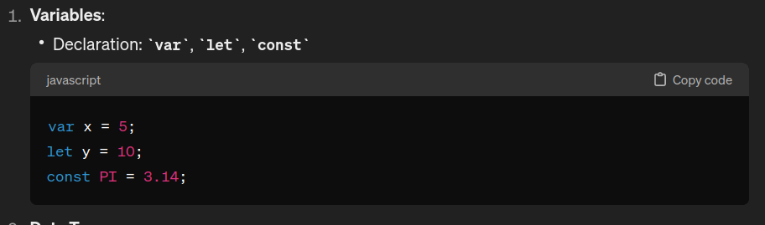
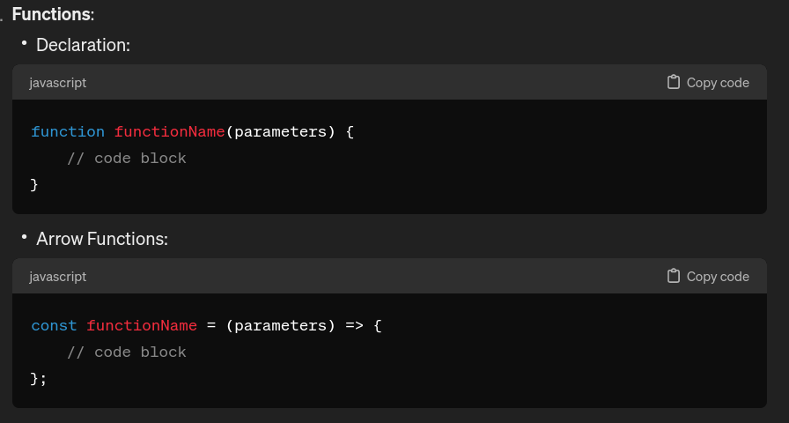
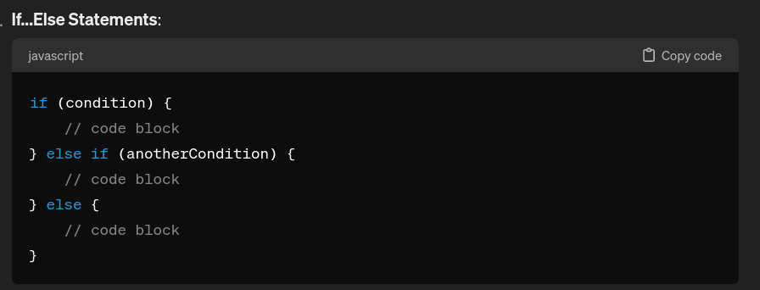
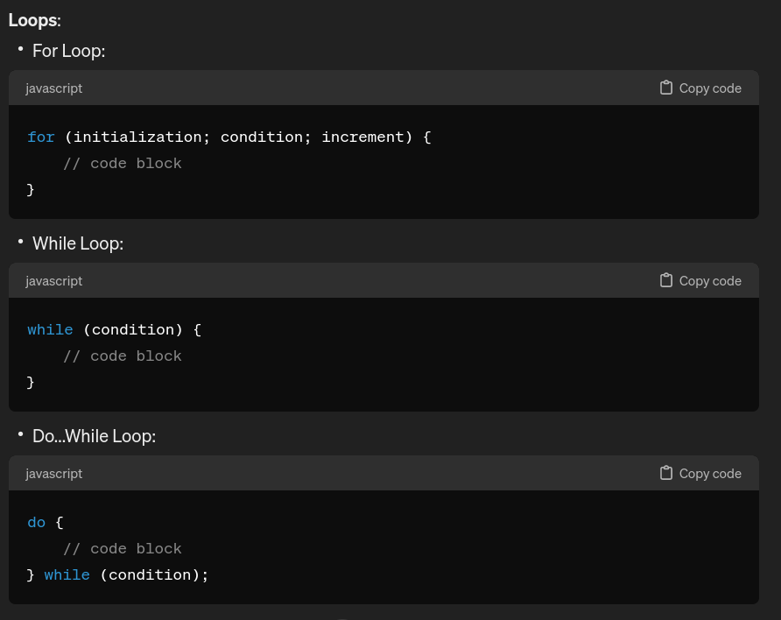

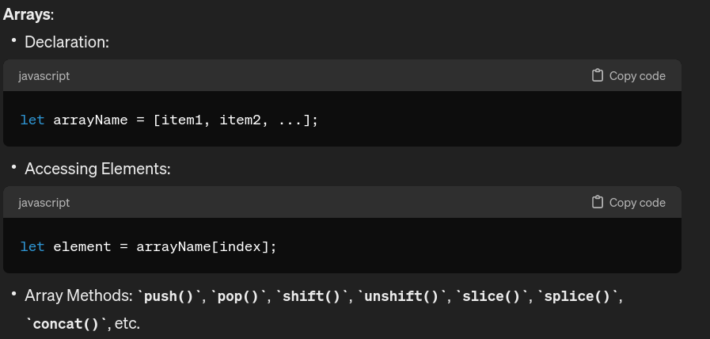
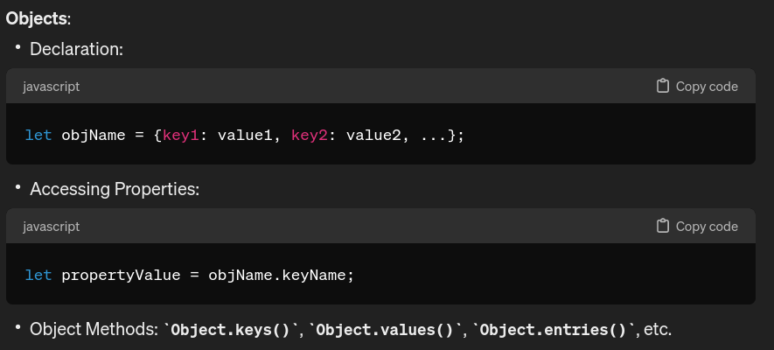

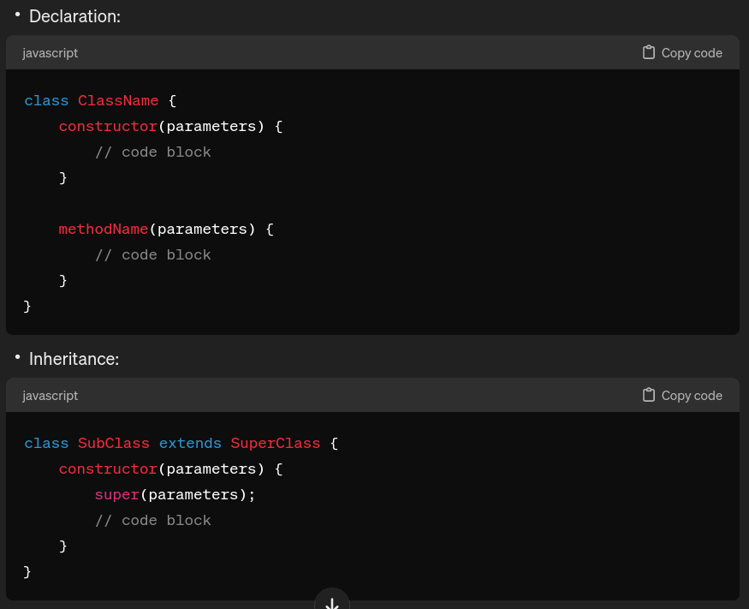
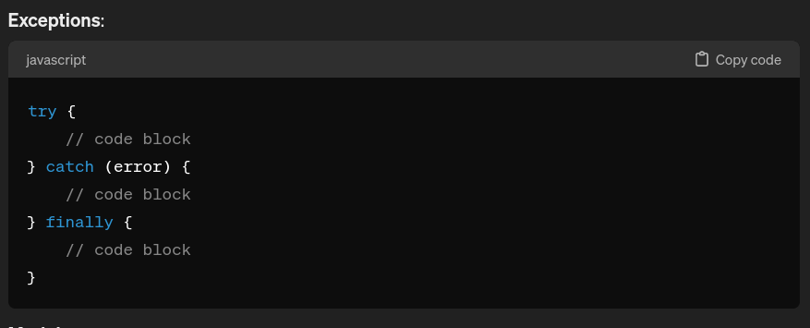
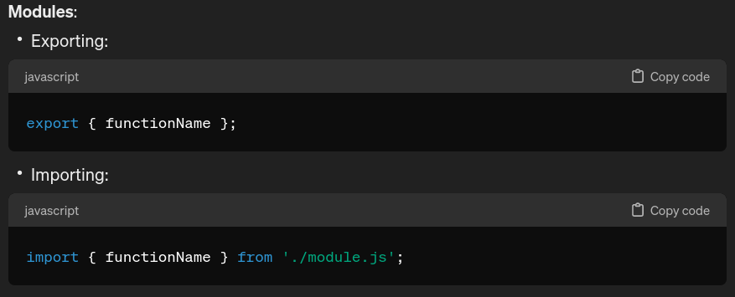
NPM (Node Package Manager):
NPM is the package manager for Node.js. You can use it to install third-party packages, manage dependencies, and run scripts. Common commands include:
  - npm install package-name: Install a package locally.
  - npm install -g package-name: Install a package globally.
  - npm start: Run the start script specified in package.json.
  - npm test: Run tests specified in package.json.
  - npm run-script script-name: Run a custom script.
These are just the basics of Node.js. Node.js has a rich ecosystem with a vast number of libraries and frameworks that you can use to build web applications, APIs, microservices, and more.

